**Property management application using salesforce**

**Introduction :**

### Salesforce

**Introduction**

Are you new to Salesforce? Not sure exactly what it is, or how to use it? Don’t know where you should start on your learning journey? If you’ve answered yes to any of these questions, then you’re in the right place. This module is for you.  
  
Welcome to Salesforce! Salesforce is game-changing technology, with a host of productivity-boosting features, that will help you sell smarter and faster. As you work toward your badge for this module, we’ll take you through these features and answer the question, “What is Salesforce, anyway?”

**What Is Salesforce?**  
Salesforce is your customer success platform, designed to help you sell, service, market, analyze, and connect with your customers.

Salesforce has everything you need to run your business from anywhere. Using standard products and features, you can manage relationships with prospects and customers, collaborate and engage with employees and partners, and store your data securely in the cloud.

So what does that really mean? Well, before Salesforce, your contacts, emails, follow-up tasks, and prospective deals might have been organized something

**Problem definition and design thinking:**

**Empathy map:**



**Brain storm:**



**Result:**

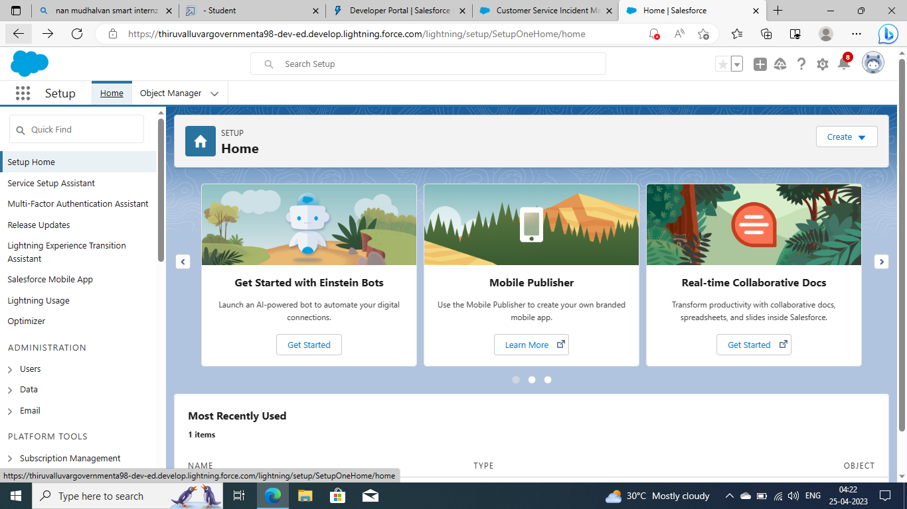

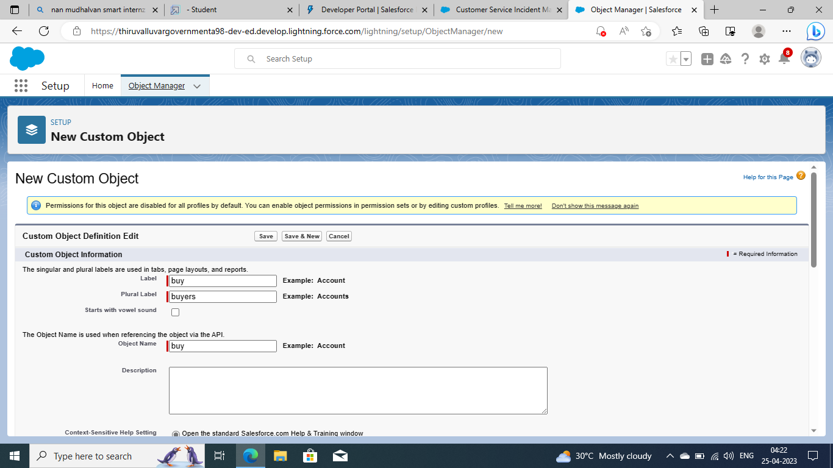

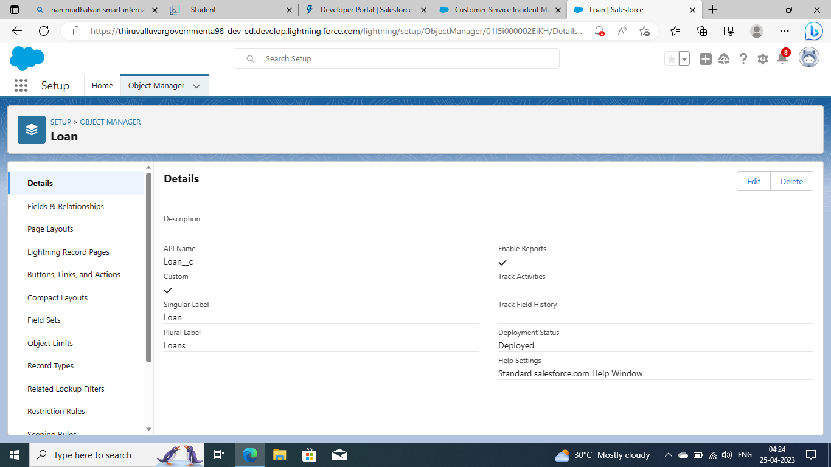

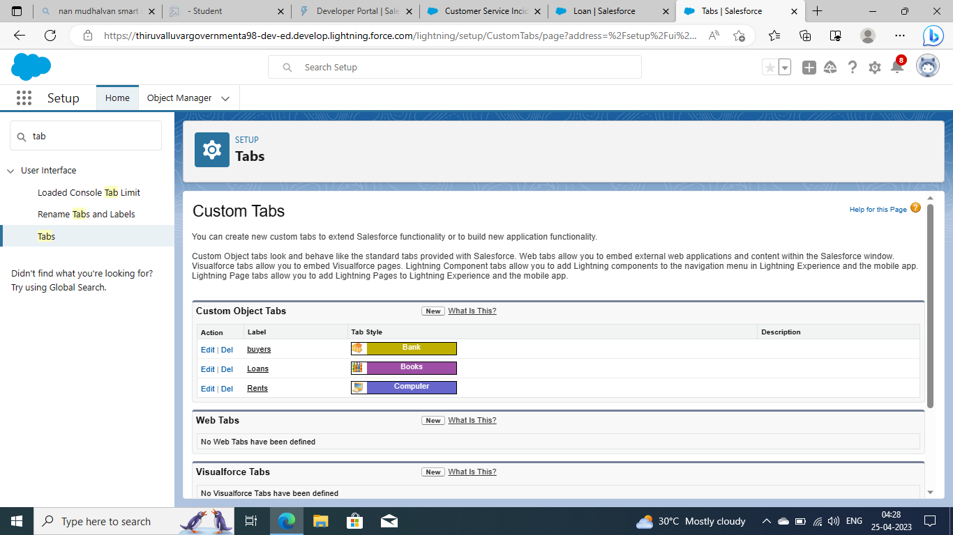

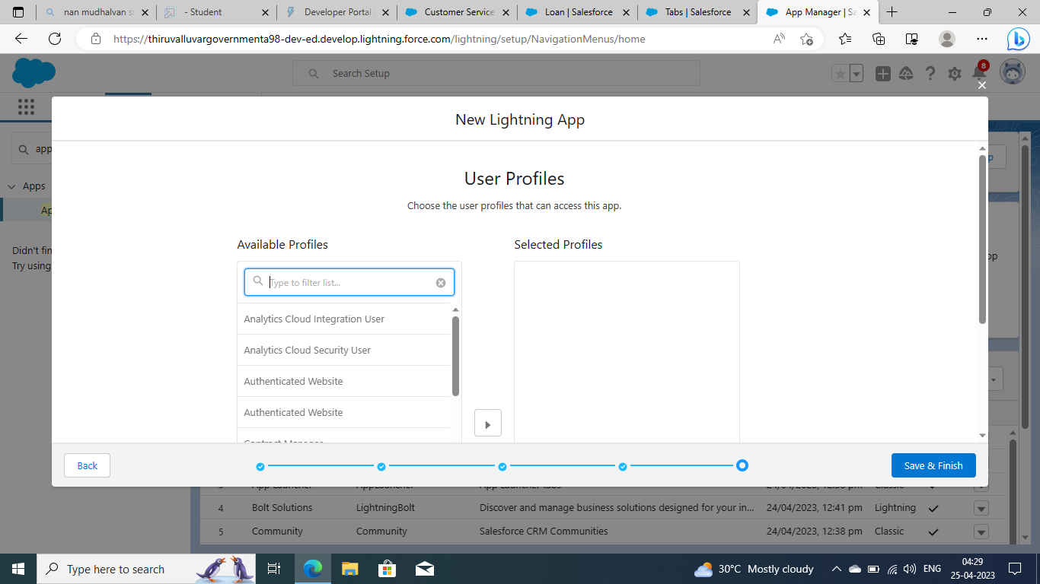

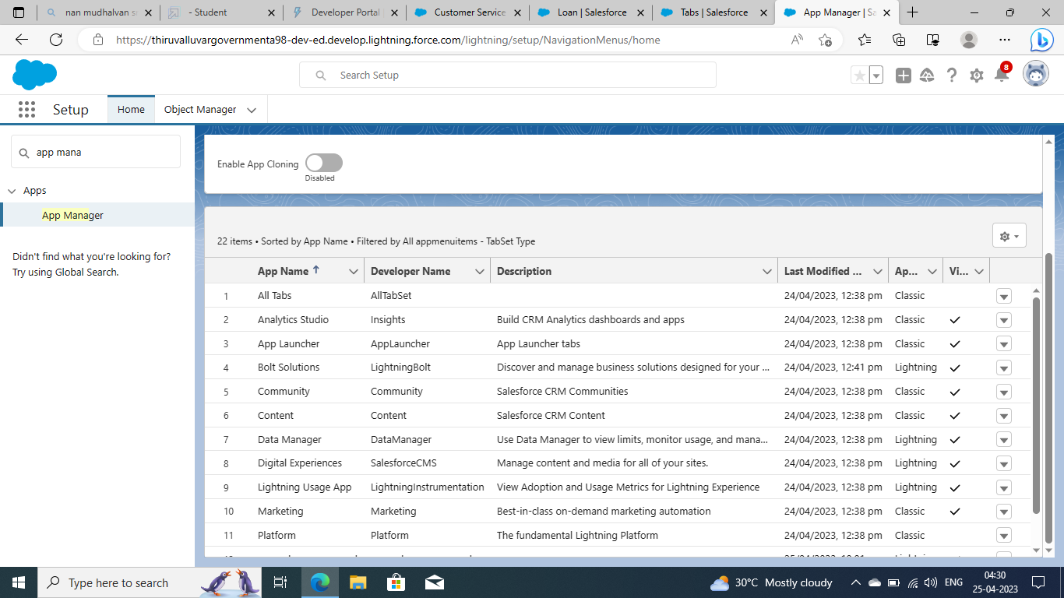

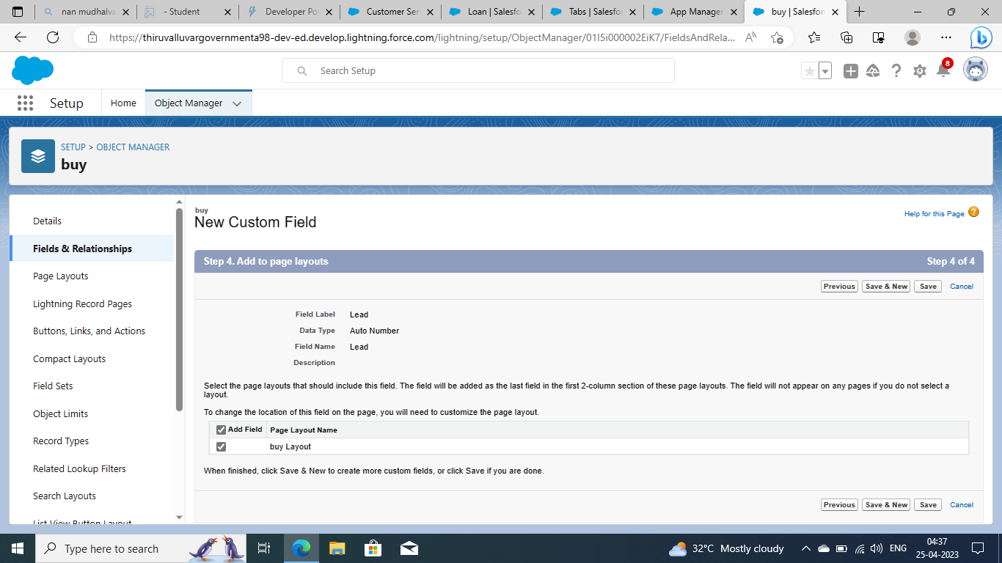

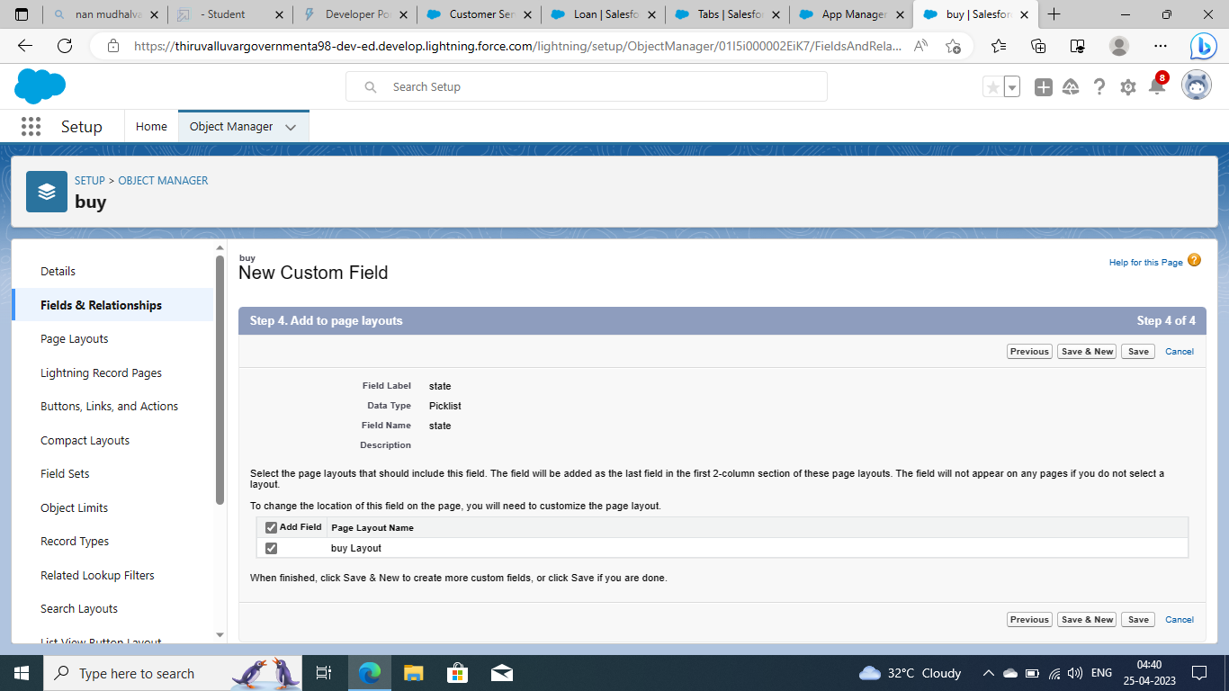

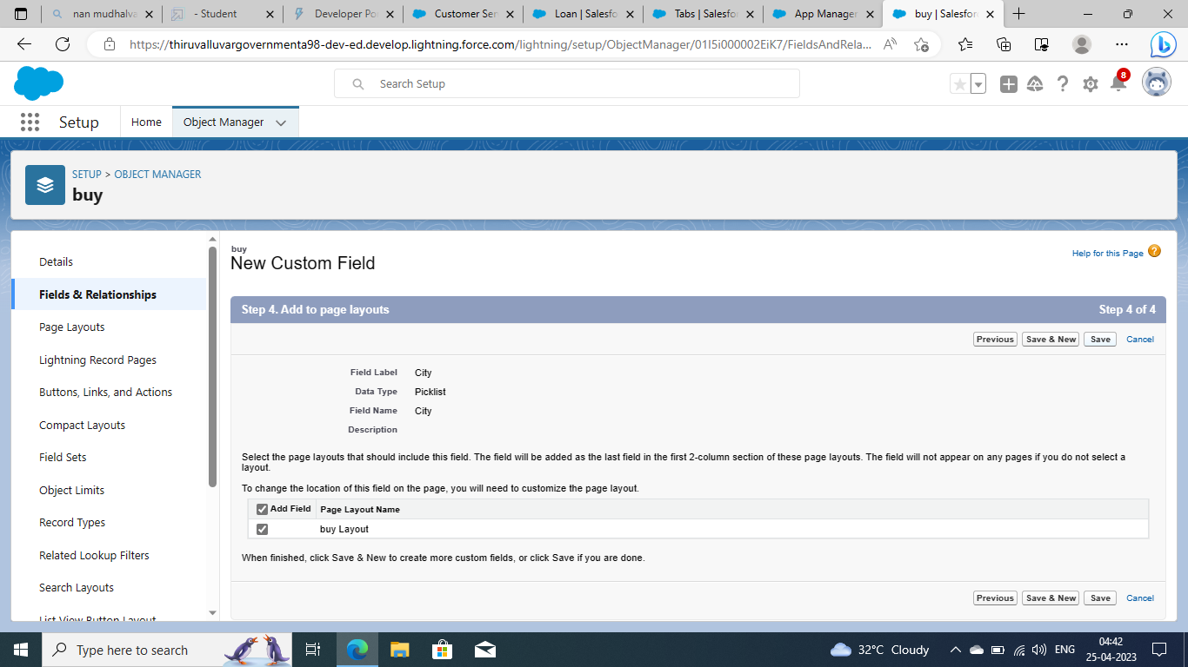

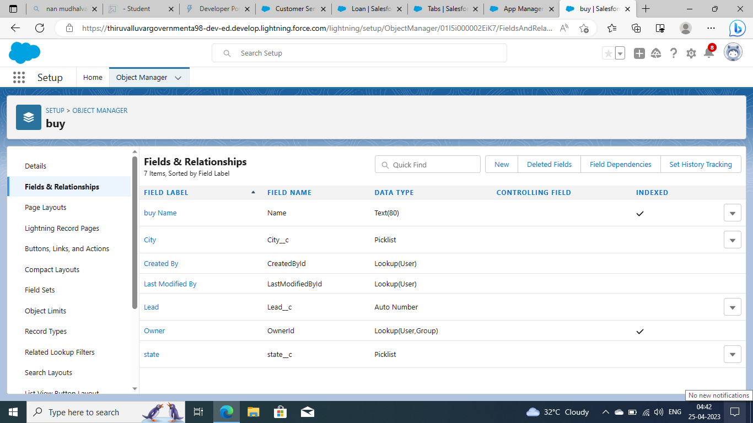

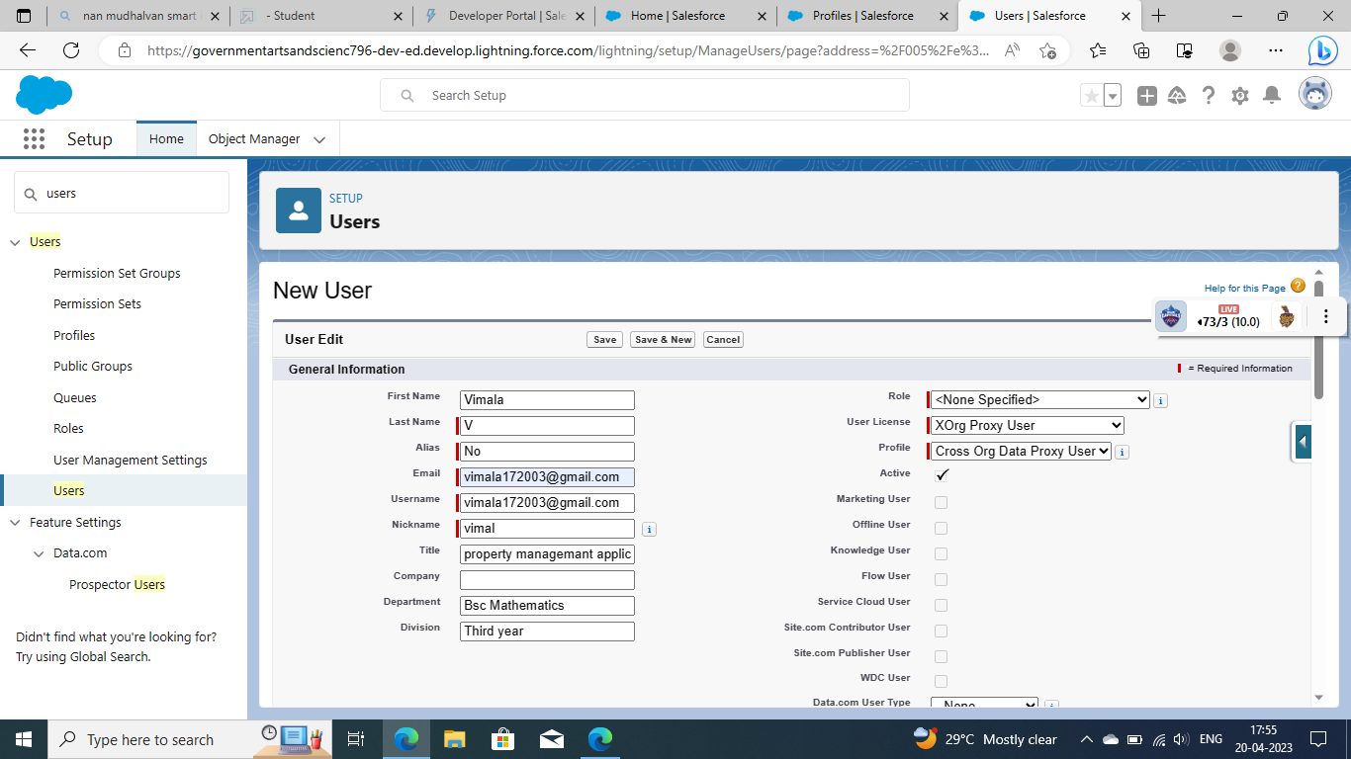

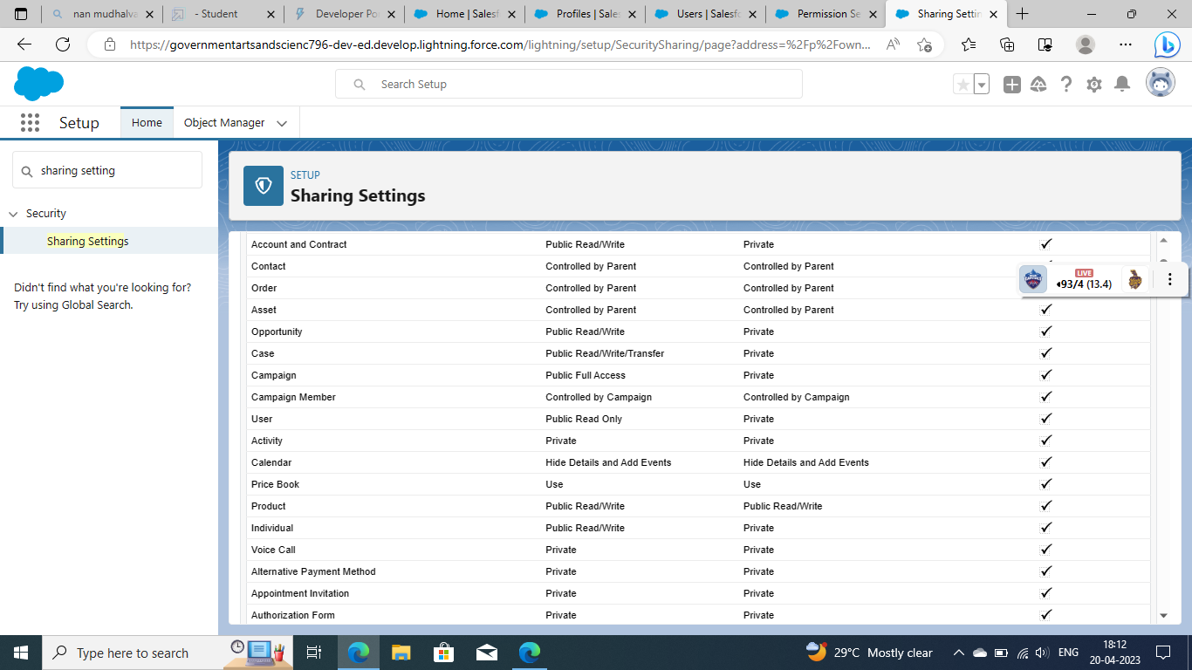

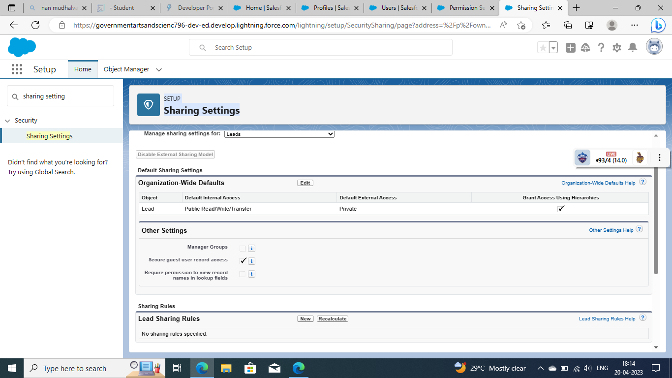

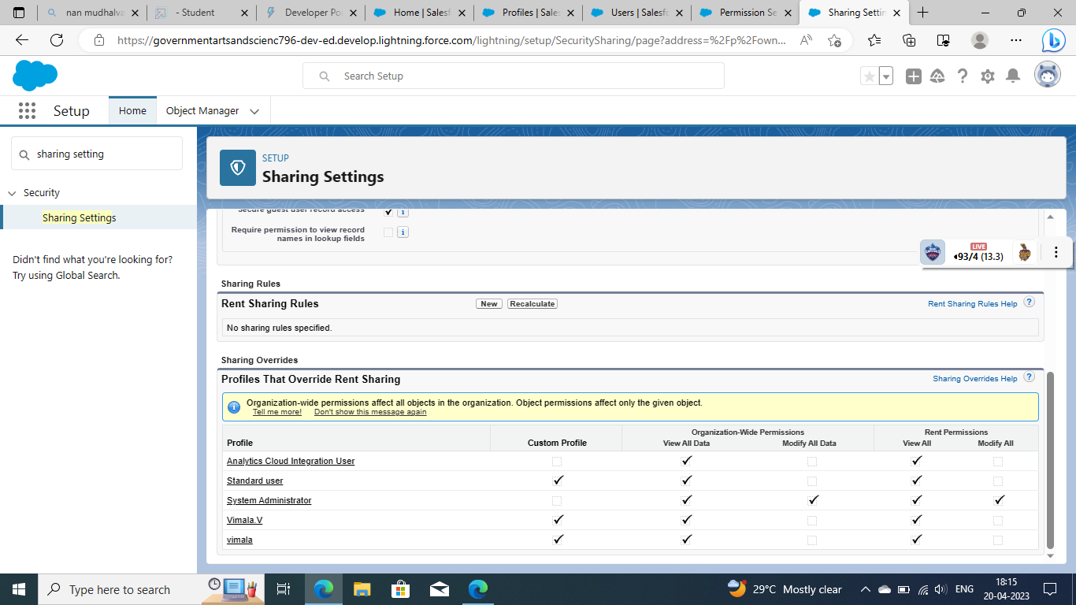

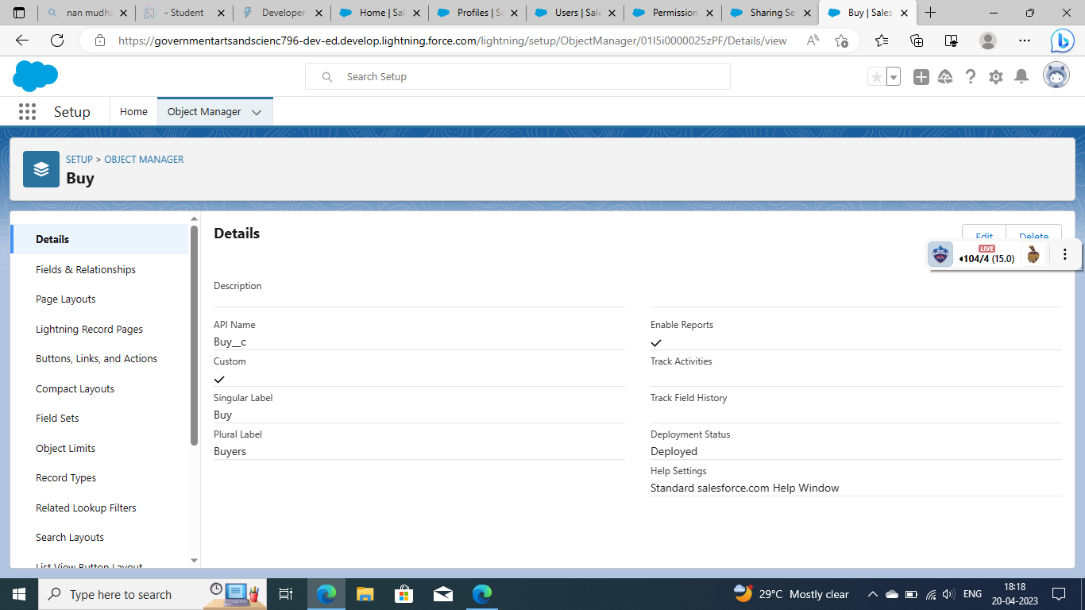

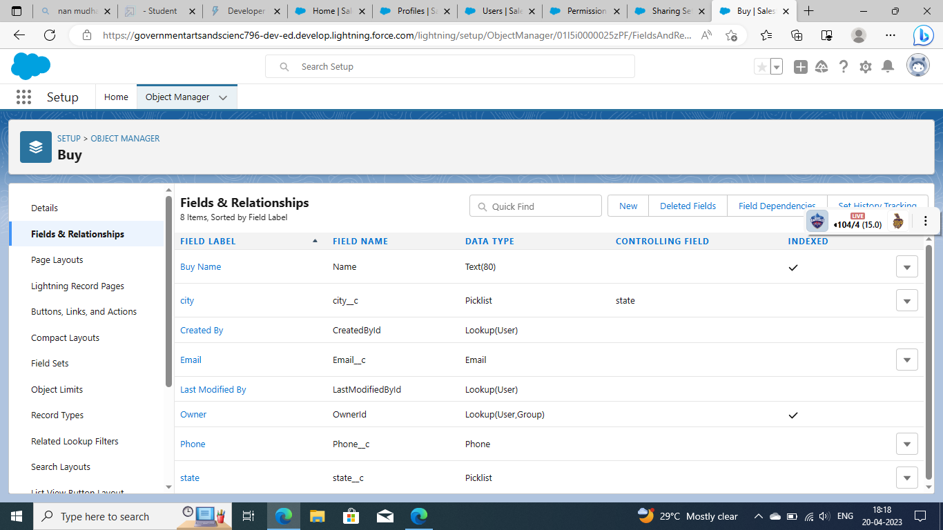

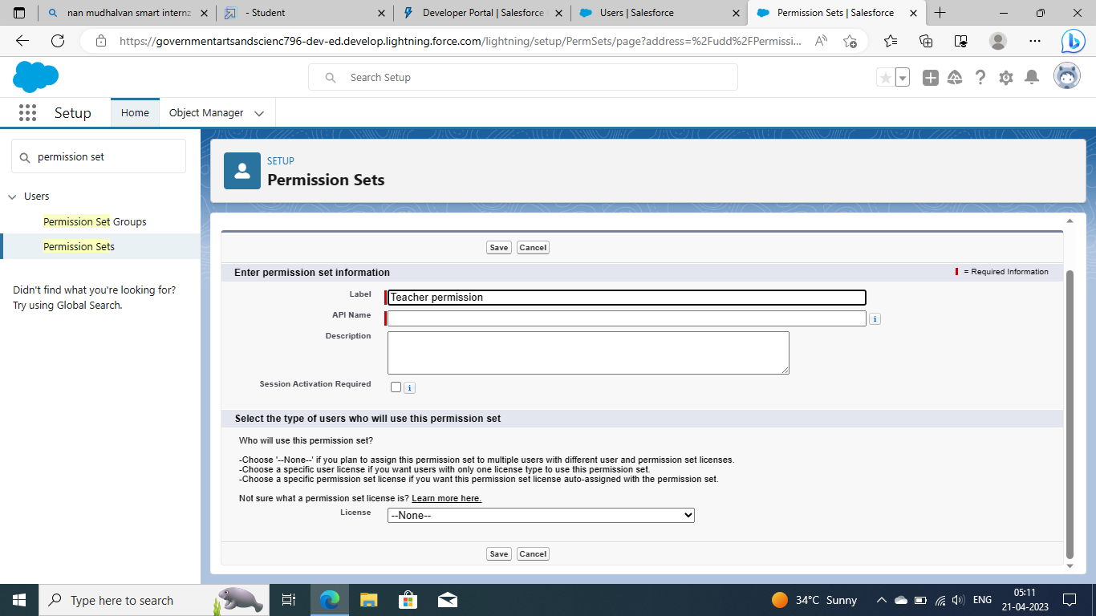

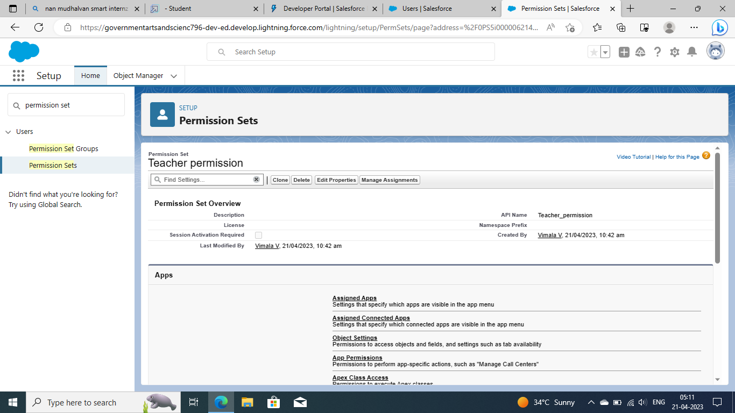

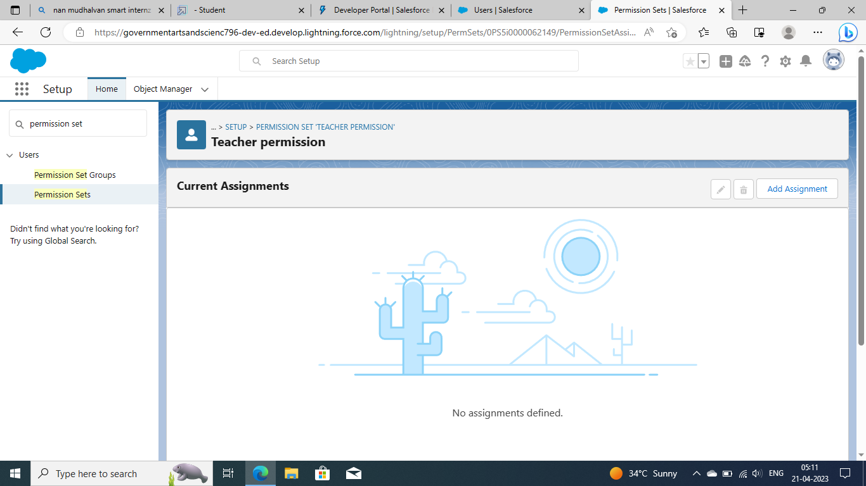

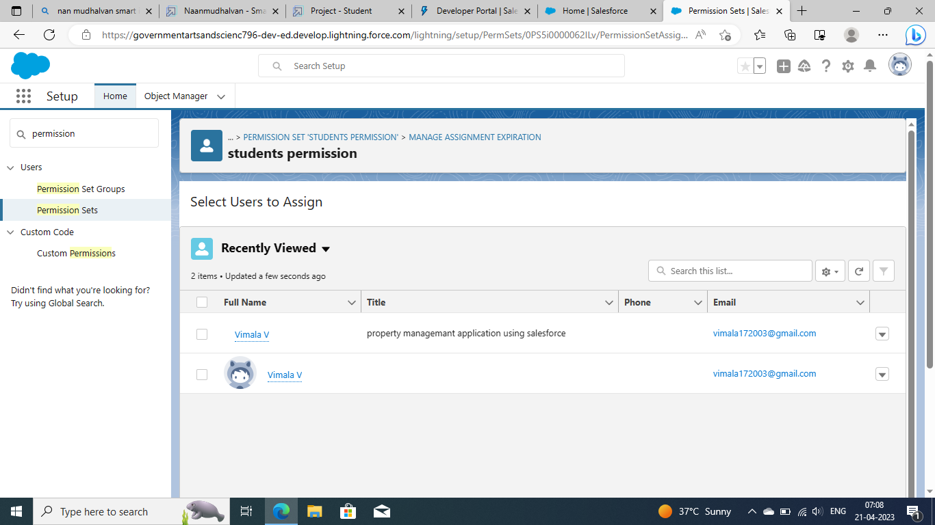

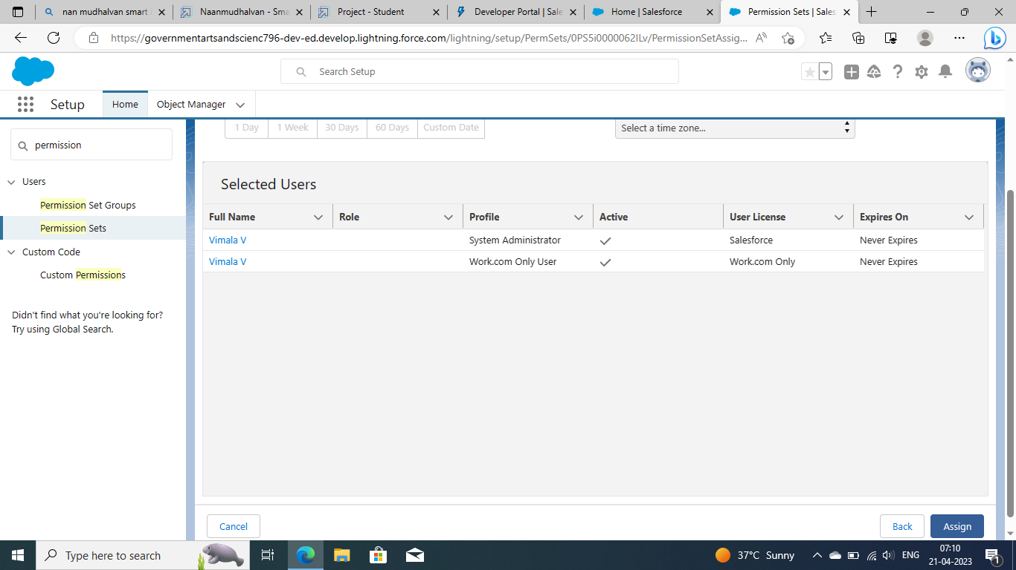

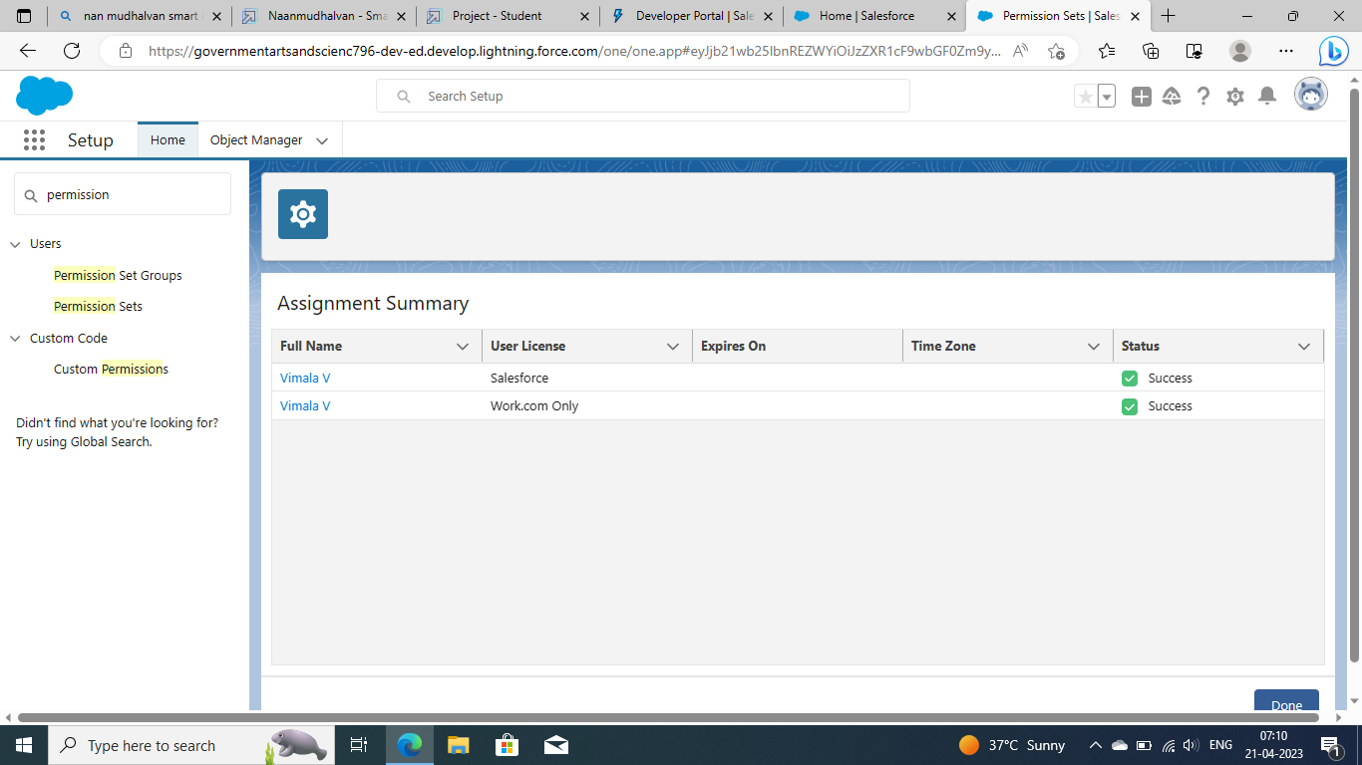

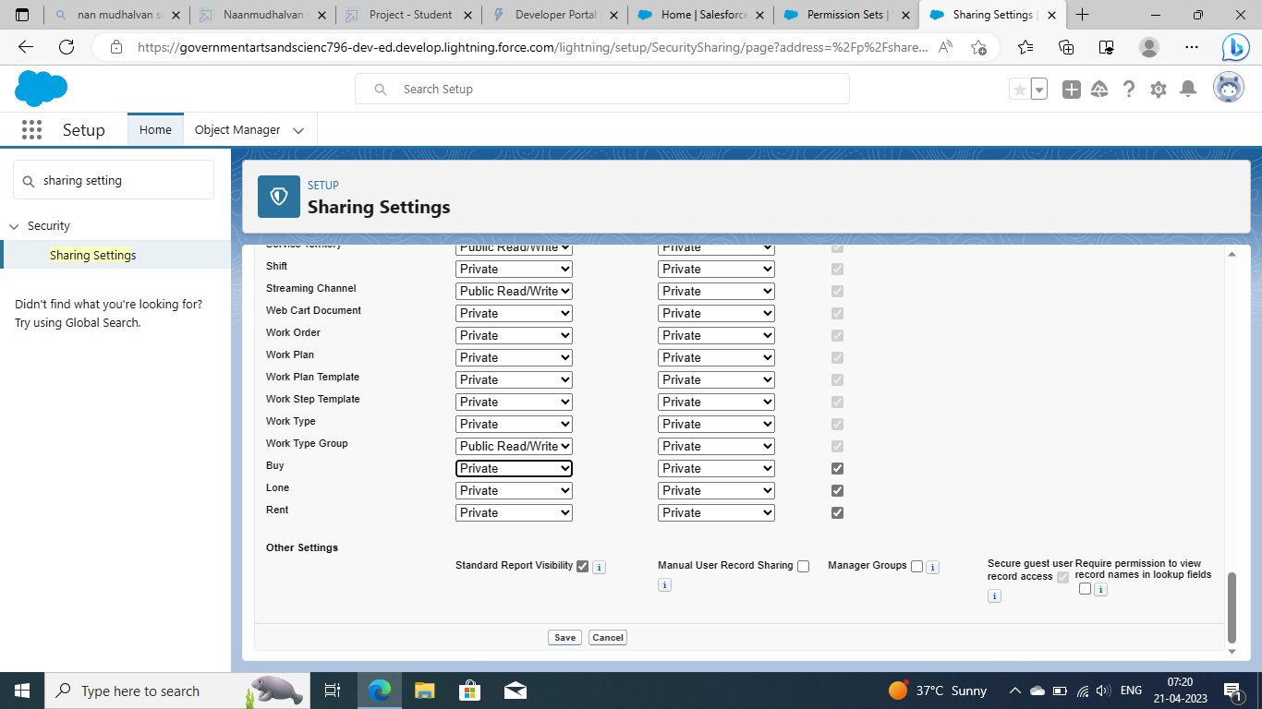

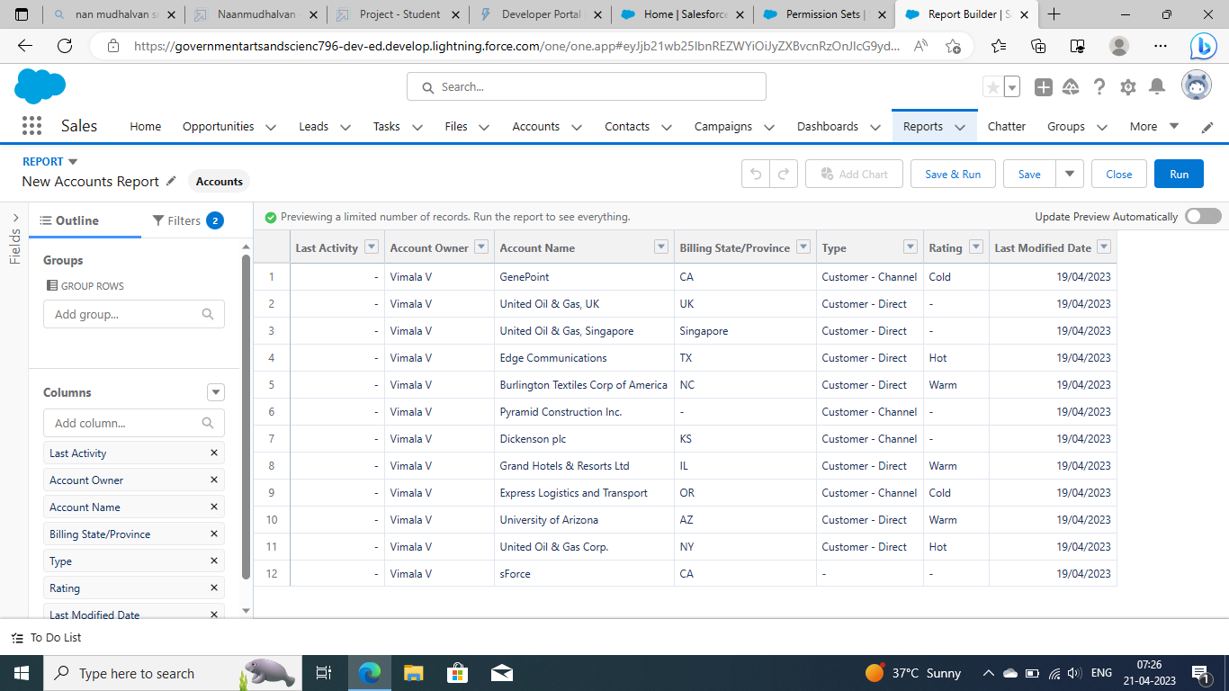

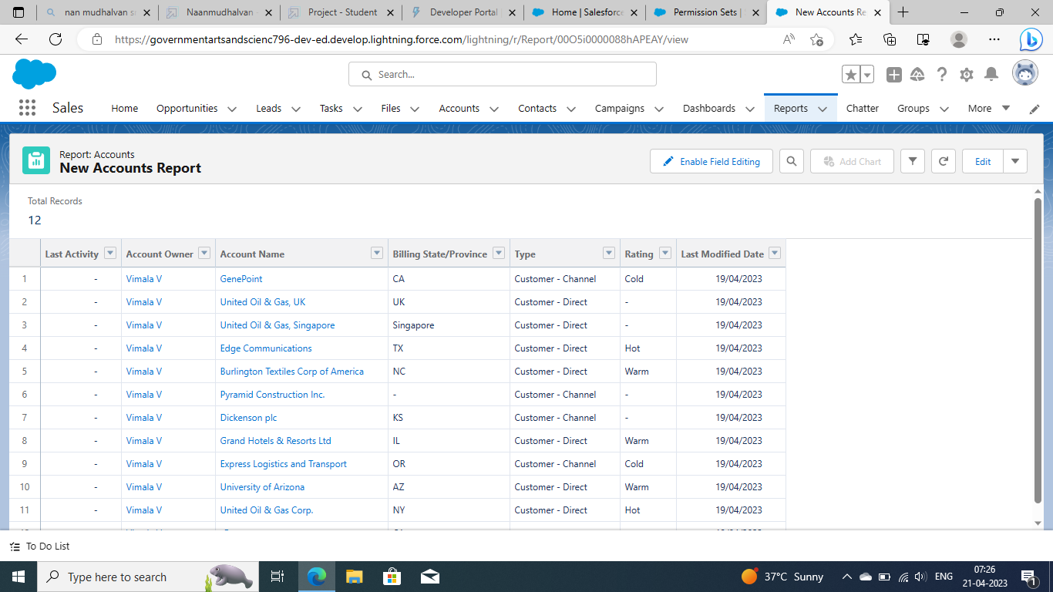

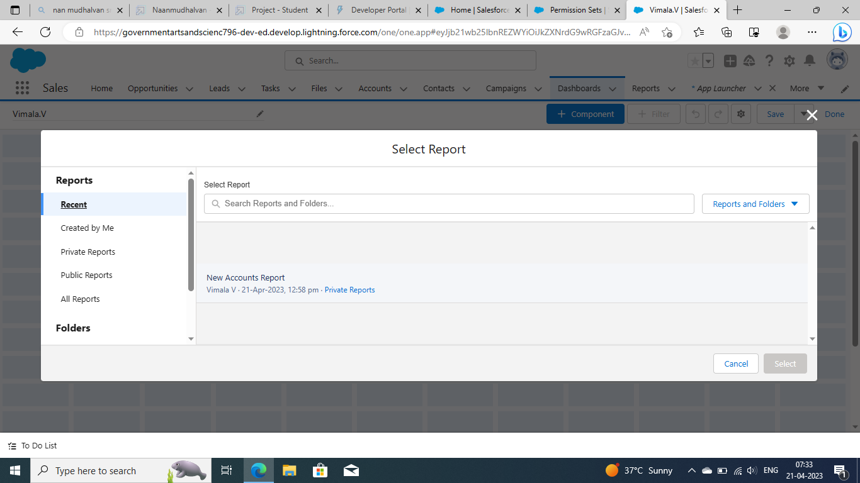

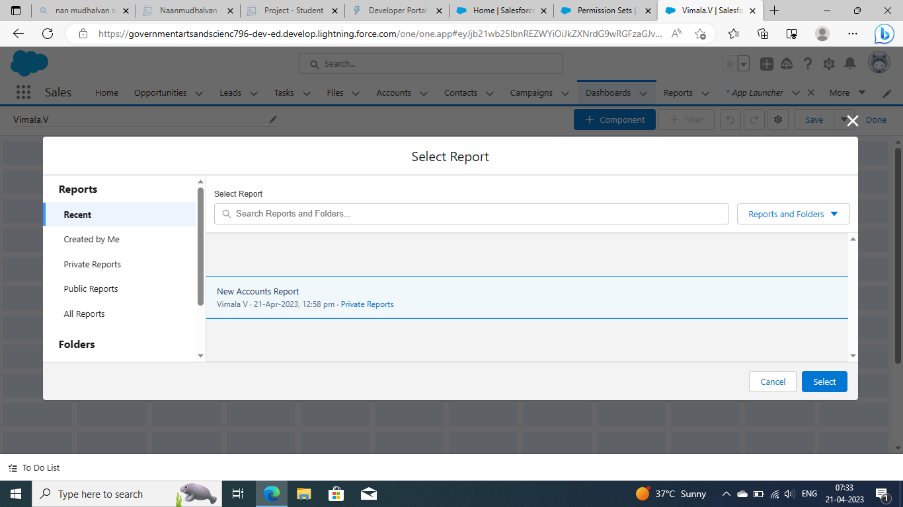

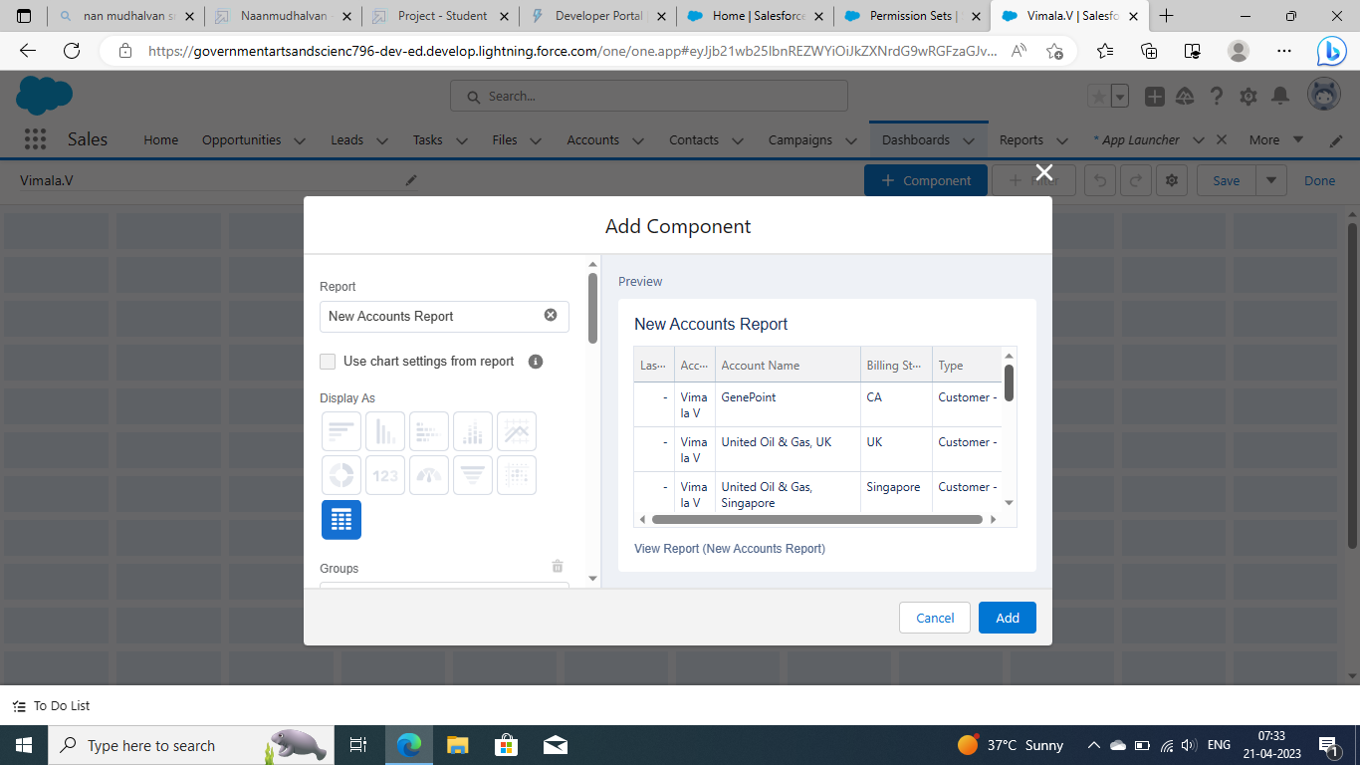

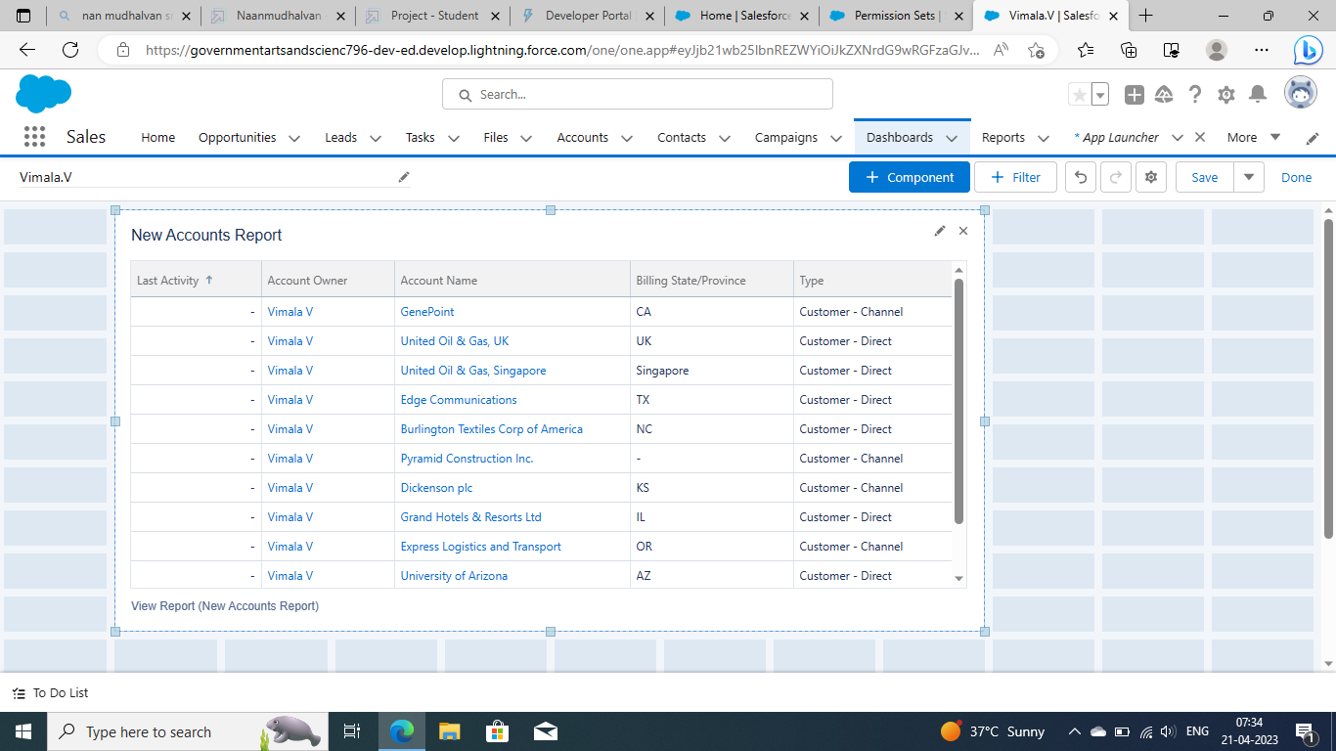

**Advantage and Disadvantage:**

**Advantages**

* Firstly, there is little to no risk when using Salesforce. Due to its low acquiring costs and low-risk management as an organization tool, there is very little to lose and a lot to benefit from.
* The database that Salesforce uses is also helpful in digitizing and organizing company sale records. Thus, improving the overall organization of a company.
* Salesforce and good customer service comes hand in hand.  It allows customization of profiles for individual customers as well as quick, organized access to individual records
* There is also no need to purchase software and hardware systems to help maintain and keep the application running.  Therefore, unlike most software, Salesforce requires no capital investment.
* The integrated solutions allow users to work more efficiently and increase the value of each part of the customer life cycle.  Moreover, Saleforce analytics and its reporting function gives its users the ability to expand their campaign capacity.  As a result, overall productivity can be increased and profit can be maximized.
* Since Salesforce is an application and no software is required, there is no need for constant updates as Salesforce will update automatically.

**Disadvantages**

* At times, there can be too much customization and the interface can be filled with cumbersome and tedious tools which can be seen as repetitive or distracting.
* Some users face difficulties in the transition between transactions.  Some have to go through multiple screens to process transactions.
* Salesforce has its own maintenance schedule since runs on its own cloud server.  As a result, there are times that the application will not be accessible.
* Users can also lose a personal touch as in the process of automation
* Salesforce contains barriers to adoption.  This means that even though Salesforce is cheap, the cost to integrate the application and redesigning their IT to incorporate it into a company is not the same as the cost of acquiring Salesforce. It is possible that the cost of integrating it can exceed the costs of the software itself.

**Applications**

Use Education Cloud objects to review and manage an applicant's information, education history, and qualifications.

Application management relies on multiple objects for modeling an applicant's information. These objects include contact, individual application, academic term, academic term enrollment, person account, person examination, person language, person education, person employment, contact profile, and case.

Here's an overview of how these admissions-focused objects work.

* The contact object represents a person who expresses interest in your institution.
* The individual application object is related to the account of the person who submits an application to an institution or a program. It can also be related to the contact who prepares an application on behalf of the applicant.
* When someone submits an application, you can automatically create a case for them. You can then assign the appropriate support staff to the case.
* An individual application record is always for a specific academic term.
* The academic term enrollment object represents the academic term that the applicant enrolls in.

## Applicant Data Record Examples

Let's see an example of how an applicant's data records can be structured in Education Cloud. Student Madison Hadzic is a senior at Daisy Bates Academy, applying to Astro University for undergraduate admission in the 2023–2024 Fall Term. Here's how the Admissions team has tracked her relationship with Astro University, starting from the time that Madison first showed interest in them. Each table summarizes the type of record that's created, when it's created, and why.

| **RECORD TYPE** | **RECORD NAME** | **RECORD CREATED WHEN...** | **RECORD REPRESENTS...** |
| --- | --- | --- | --- |
| Contact | Madison Hadzic | Madison attended an Astro University virtual recruiting event during the summer between her junior and senior years, and signaled her intent to apply. | A student with qualified interest in attending Astro University. |
| Individual Application | IA-2681 | Madison submits her application. | A student's admissions application. |
| Application Case | 00001003 | Madison submits her application to Astro University. | The case that's assigned to an applicant. |

**Conclusion:**

In conclusion, Salesforce CRM is a cloud-based platform which helps you to manage the sales, marketing, lead generation, customer service and many other functions. Hope You got more information about the benefits of using the Salesforce platform and what it does.

**Future Scope:**

So, does Salesforce have a future? With over 150,000 organizations utilizing Salesforce across the world to fuel their growth, it is the most popular and widely used CRM platform confirming the future of Salesforce to be promising. Industries have adopted Salesforce for their daily procedures and work needs across the board. Small-scale companies to Internet behemoths like Google and Facebook use Salesforce’s services and products to solve business challenges.

Salesforce’s ability to customize, build, and distribute apps has sparked innovation and accelerated cloud adoption in the advent of digital technology.

It is predicted that Salesforce will be widely used in retail, communications, and media industries. Within the Salesforce ecosystem, the financial services and manufacturing industries are expected to grow the fastest, among others. A Salesforce certification can help you future-proof your career if you already work in one of these fields. So, you are already ahead of the game!

Businesses are rapidly digitizing, and the cloud is an important factor in their success. As a result, strengthening abilities in cloud technologies like Salesforce will act as a catalyst for success.

Now that you have the slightest idea of what Salesforce hype is all about, let’s uncover the scope of Salesforce and the career opportunities the ecosystem offers.

**Appendix:**

Team Leader:

V.Vimala

https://trailblazer.me/id/vima06

Team Members:

* 1. V. Tamilselvam

https://trailblazer.me/id/tamiv12

* 1. N. Yamuna

https://trailblazer.me/id/yamun71

* 1. P. Vinodhini

https://trailblazer.me/id/vinop20

* 1. K. Dinakaran